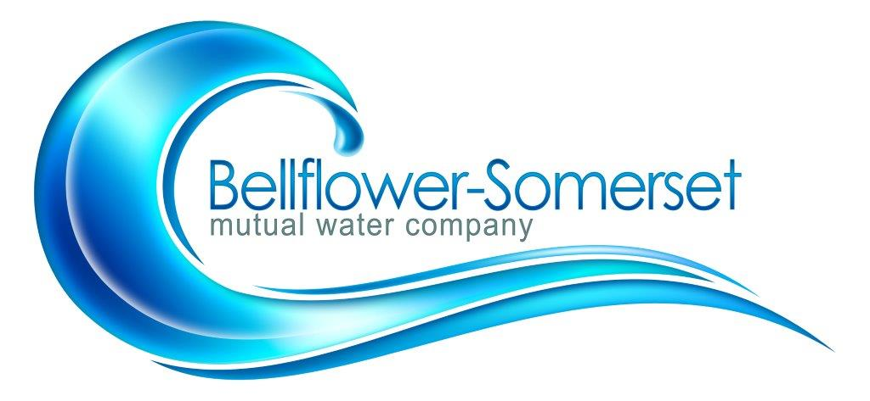

BELLFLOWER-SOMERSET MUTUAL WATER COMPANY
REGULAR MEETING OF THE BOARD DIRECTORS

December 16, 2019
4:30 P.M.
AGENDA

- Call to Order

- Addition(s) to the Agenda
- Approve the Minutes of the Regularly Scheduled Meeting of November 18, 2019
- Approve Payment of Bills
- Public Comment
Discussion/Action Items:
6. Old and New Business:
- Date change of January and February Board Meetings due to Holidays
Reports:

7.Legislative Updates

8. Project Updates:
A. Leahy Well
B. Courthouse Mainline Update

9. Other Reports
A. Water Quality:
- PWAG:
- Maintenance/Safety:
- Watermaster Plan Update:
- Water Bill Presentation:

10. Personnel Committee
11. Finance Committee
Executive Session: (Personnel\Finance\ Legal Matters)

Adjournment
Next board meeting: To be Determined

