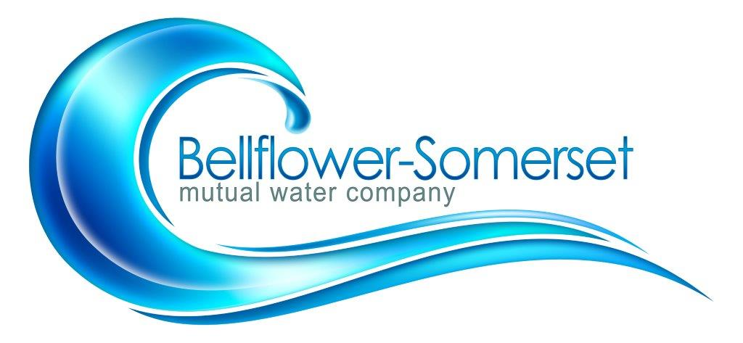

BELLFLOWER-SOMERSET MUTUAL WATER COMPANY
REGULAR MEETING OF THE BOARD DIRECTORS

November 18, 2019
4:30 P.M.
AGENDA

- Call to Order

- Addition(s) to the Agenda
- Approve the Minutes of the Regularly Scheduled Meeting of October 21, 2019
- Approve Payment of Bills
- Public Comment
Discussion/Action Items:
6. Old and New Business:
- Discuss and approve company policy to meet requirements for SB 998
- Discuss options of PFOS and PFOA
- Mission Statement
Reports:

7.Legislative Updates

8. Project Updates:
A. Leahy Well
B. Courthouse Mainline Update
C. CB54 Renovations and Telemetry Status Update

9. Other Reports
A. Water Quality
- PWAG:
- Maintenance/Safety:
- Watermaster Plan Update:
- Water Bill Presentation:

10. Personnel Committee
11. Finance Committee
Executive Session: (Personnel\Finance\ Legal Matters)

Adjournment
Next board meeting: December 16, 2019

