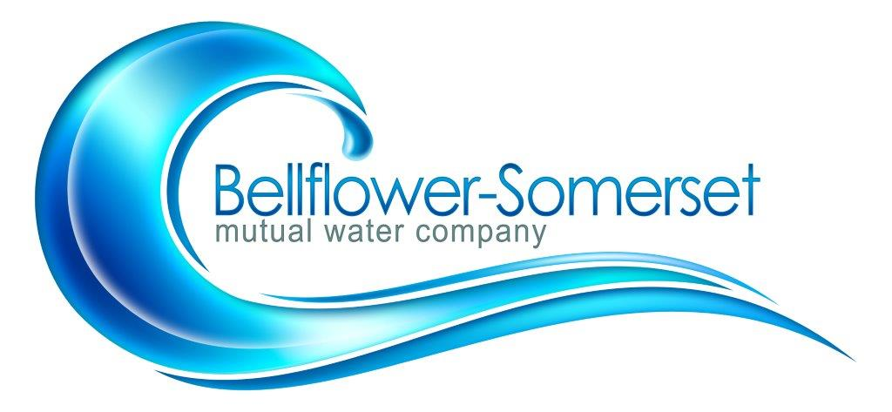

BELLFLOWER-SOMERSET MUTUAL WATER COMPANY
REGULAR MEETING OF THE BOARD DIRECTORS

October 21, 2019
4:30 P.M.
AGENDA

- Call to Order

- Addition(s) to the Agenda
- Approve the Minutes of the Regularly Scheduled Meeting of September 16, 2019
- Approve Payment of Bills
- Public Comment
Discussion/Action Items:
6. Old and New Business:
- Discuss PFOS / PFOA
- Discuss and approve company policy to meet requirements for SB 998
- Mission Statement
Reports:

7.Legislative Updates

8. Project Updates:
A. Leahy Well
B. Courthouse Mainline Update
C. CB54 Renovations and Telemetry Status Update

9. Other Reports
A. PWAG: Cross Walk for Risk and Resiliency Plan
B. Maintenance/Safety:

10. Personnel Committee
11. Finance Committee
Executive Session: (Personnel\Finance\ Legal Matters)

Adjournment
Next board meeting: November18, 2019

