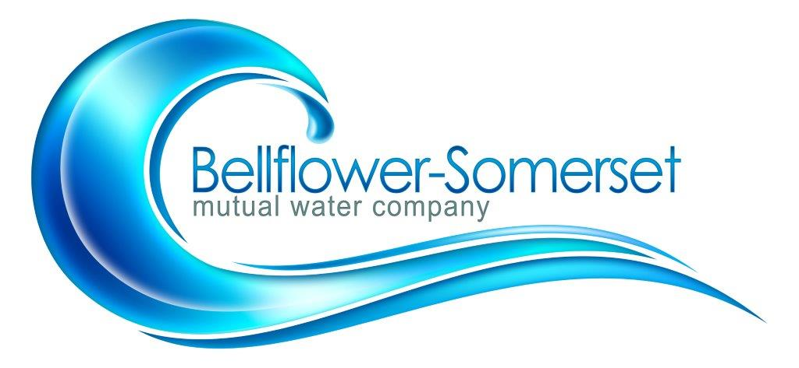

BELLFLOWER-SOMERSET MUTUAL WATER COMPANY
MINUTES OF REGULAR MEETING OF THE BOARD DIRECTORS

November 18, 2019
4:30 P.M.
Location: Company Office

ROLL CALL OF BOARD OF DIRECTORS
Eric Ikeda
Leo Struiksma
Robert Wilson
Cheryl Harris

ABSENT
Rick Cook

OTHERS PRESENT
Steve Lenton, General Manager
Tom Coleman, Consultant
Wesley Whitehead, Shareholder

- Call to Order
President Cook called to order a regular meeting of the Board of Directors at 4:31p.m. at the company office located 10016 Flower St, Bellflower, CA
- Additions to the Agenda
NONE

- Approve the Minutes of the Board Meeting held October 21, 2019
Motion by Director Ikeda, seconded by Director Wilson and carried to approve the minutes of October 21, 2019.

- Approve Payment of Bills
Motion by Director Harris, seconded by Director Wilson and carried to approve payment of the bills as presented.
- Public Comment
Mr. Whitehead inquired about the estimated cost of the discussion last month if BSMWC has to go to 100% MET water due to PFOS/PFOA. Numbers were calculated and estimated to be about $2.00 per unit.

Discussion/Action Items:

- Old and New Business:

- Discuss and Approve new policy for SB998 shut off policy.
The Rules and Regulation policy changed was discussed by the board.
A motion to adopt the changes was made by Director Ikeda and seconded by Director Harris. And passed by a unanimous vote of the board.

- Discussion of Pfos options. Mr. Lenton informed the board that all wells have been tested for PFOS/PFOA for company use. The Leahy well is being tested for an amount of $70,000.00. He also reported that he has been in communication with multiple treatment companies and is awaiting actual cost estimates to install and operate treatment systems.

- Mission Statement:
The board of directors were given 3 options for a mission statement prepared by staff. After discussion, the board adopted option 3 with modifications. The new mission statement of BSMWC is: “Bellflower Somerset Mutual water Company provides safe quality drinking water and trusted service to our shareholders.”

Reports:

- Legislative Updates
(no update)

- Projects Update
- Leahy Well:
Mr. Lenton informed the board of directors that the permit is on the final submission, once the cost for permits is received and paid. A building permit will be issued.

- Courthouse Pipeline:
No update

- CB 54 Improvement Project:
Mr. Lenton informed the board of directors that CB 54 is complete and fully operational.
- Other Reports
- Water Quality- Mr. Lenton informed the board that Quarterly 1-4 Dioxane results are in and present in our water

- PWAG – Mr. Lenton informed the board that this month he will be attending a kick off meeting to start the first Cross Walk for Risk and Resiliency Plan:

- Maintenance – Safety – Harassment:
None

- Watermaster Plan Update:
Mr. Lenton informed the board that AKM Engineering has a goal date of March for completion of the master plan.

- Water bill Presentation- Mr. Lenton informed the board that the most cost-effective way of re doing the customers bills is to start with a template of Rowland water Bills. After looking at their bill, the board approved to follow the template from Rowland water with no changes excluding name and address changes.

- Finance Committee:
None
10.Personnel Committee:
items will be discussed in executive session.

Executive Session: (Personnel Matters)

Adjournment
The President asked if there was any further business to come before the Board of Directors, there being none, motion made by Director Struiksma, seconded by Director Ikeda, carried to adjourn the meeting.

________________________
Rick Cook, Board President

ATTEST:

__________________________
Eric Ikeda, Secretary

